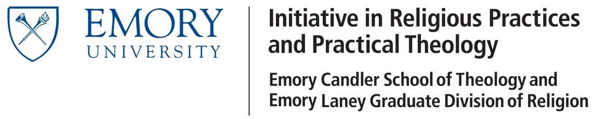

Conference Participation Support Application

Date ____________________________

Student

Email

Course of Study

What year did you start in the GDR? ______________

When did you enter candidacy? ________________ Enter month/year. If you're not in candidacy, enter n/a.

Please attach an abstract of your presentation, if applicable, and a brief statement (200 words) about how this participation will advance your graduate work in religious practices and practical theology.
Conference

Conference

Dates and Location

Budget

Amount Requested: _________________

Please attach a detailed budget.

For reimbursement, submit receipts of all expenses, with a cover sheet listing expenses and total requested. Receipts smaller than 8.5X11 should be taped to a plain sheet of 8.5X11 paper. In general, follow applicable university rules and policies.

Please submit a report to Professor Phillips following your return from the conference (250 words), describing what it has contributed to your work on religious practices and practical theology.

Submit this application to L. Edward Phillips
Room 410, Rita Ann Rollins Building
1531 Dickey Drive
Lphill6@emory.edu

