Leadership Role in a Congregation or Faith Community
Students in the Concentration in Religious Practices and Practical Theology are normally expected to have served in some leadership role in a religious community. Many students will have such experience prior to coming to Emory. Others may need to augment their experience and skills through practice-oriented internships that provide supervised experience in such areas as preaching, teaching, community outreach, counseling, worship leadership, or some other practice of leadership in religious communities. This experience can be gained in a synagogue, church, mosque, or other religious communal or institutional setting.

Name:

Course of Study:

Leadership Role in a Congregation or Faith Community:

Date of completion:

Description:
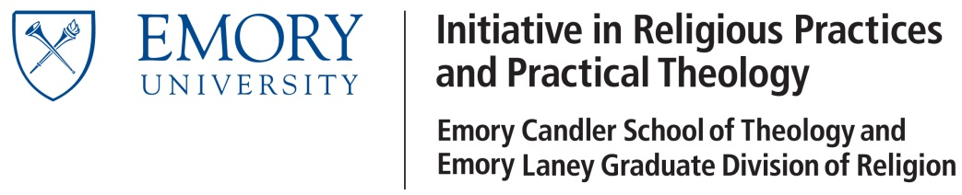

Submit this application to L. Edward Phillips,
Room 410, Rita Anne Rollins Building
1531 Dickey Drive
Lphill6@emory.edu

